Portarlington (PANA)
Monday 23 February 2026
09:47

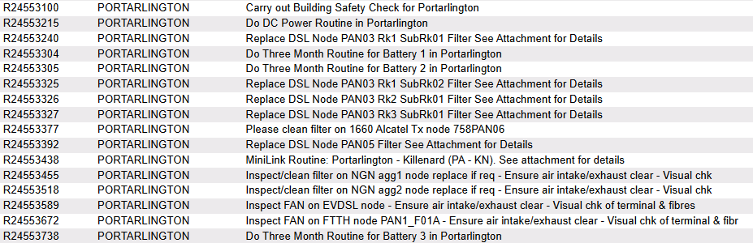

R23619307 | Carry out Building Safety Check for Portarlington
R23619426 | Do DC Power Routine in Portarlington
R23619451 | Replace DSL Node PAN03 Rkl SubRk01 Filter See Attachment for Details
R23619515 | Do Three Month Routine for Battery 1 in Portarlington
R23619516 | Do Three Month Routine for Battery 2 in Portarlington
R23619536 | Replace DSL Node PAN03 Rkl SubRk02 Filter See Attachment for Details
R23619537 | Replace DSL Node PAN03 Rk2 SubRk01 Filter See Attachment for Details
R23619538 | Replace DSL Node PAN03 Rk3 SubRk01 Filter See Attachment for Details
R23619589 | Please clean filter on 1660 Alcatel Tx node 758PAN06
R23619604 | Replace DSL Node PAN05 Filter See Attachment for Details
R23619649 | MiniLink Routine: Portarlington - Killenard (PA - KN)_ See attachment for details
R23619668 | Inspect/clean filter on NGN agg1 node replace if req - Ensure air intake/exhaust clear - Visual chk
R23619730 | Inspect/clean filter on NGN agg2 node replace if req - Ensure air intake/exhaust clear - Visual chk
R23619801 | Inspect FAN on EVDSL node - Ensure air intake/exhaust clear - Visual chk of terminal & fibres
R23619883 | Inspect FAN on FTTH node PANI FOIA - Ensure air intake/exhaust clear - Visual chk of terminal & fibr
R23619948 | Do Three Month Routine for Battery 3 in Portarlington

Please clean/replace filter on PAN-MSAN

Do Three Month Routine for Battery 1,2,3 in Portarlington

Battery 1 — Overall Voltage: 53.69 V
1 | 2 | 3 | 4 | 5 | 6 | 7 | 8 | 9 | 10 | 11 | 12 | 13 | 14 | 15 | 16 | 17 | 18 | 19 | 20 | 21 | 22 | 23 | 24
2.24 | 2.22 | 2.2 | 2.23 | 2.22 | 2.23 | 2.29 | 2.21 | 2.21 | 2.22 | 2.22 | 2.21 | 2.26 | 2.26 | 2.22 | 2.24 | 2.24 | 2.23 | 2.23 | 2.22 | 2.23 | 2.23 | 2.23 | 2.24

Battery 2 — Overall Voltage: 53.69 V
1 | 2 | 3 | 4 | 5 | 6 | 7 | 8 | 9 | 10 | 11 | 12 | 13 | 14 | 15 | 16 | 17 | 18 | 19 | 20 | 21 | 22 | 23 | 24
2.27 | 2.28 | 2.27 | 2.28 | 2.28 | 2.28 | 2.29 | 2.28 | 2.25 | 2.24 | 2.26 | 2.27 | 2.16 | 2.23 | 2.2 | 2.19 | 2.2 | 2.22 | 2.2 | 2.2 | 2.19 | 2.25 | 2.28 | 2.9

Battery 3 — Overall Voltage: 53.69 V
1 | 2 | 3 | 4 | 5 | 6 | 7 | 8 | 9 | 10 | 11 | 12 | 13 | 14 | 15 | 16 | 17 | 18 | 19 | 20 | 21 | 22 | 23 | 24
2.28 | 2.29 | 2.28 | 2.28 | 2.28 | 2.27 | 2.28 | 2.28 | 2.2 | 2.2 | 2.28 | 2.28 | 2.2 | 2.25 | 2.21 | 2.19 | 2.21 | 2.17 | 2.19 | 2.19 | 2.19 | 2.19 | 2.19 | 2.19

Do DC Power Routine in Portarlington

Rectifiers | 5
DC Load | 138
Boost Voltage | 54
Float Voltage | 53.7

Alarm Limits
Low Voltage | 47
High Voltage | 58
High Load | 99%
High Temperature | 28 °C

Low Voltage, High Voltage, High Load and High Temperature alarms were triggered but only 2 alarms were visible to AC Mains fail and , Over and Under voltage alarm.

